Question 3
(a)
Statistical software output:
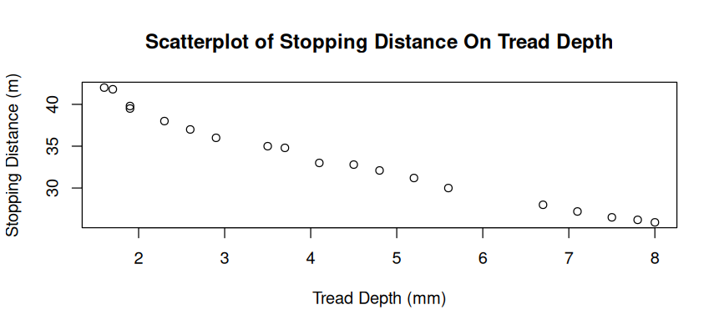

(b) (i)
Statistical software output:
Pearson's product-moment correlation

data: Depth and Distance
t = -24.771, df = 17, p-value = 8.839e-15
alternative hypothesis: true correlation is not equal to 0
95 percent confidence interval:
-0.9948849 -0.9642455
sample estimates:
cor
-0.9864292

Answer:
-0.9864292 or -0.99

(ii)
Answer:
Strong Negative Linear Relationship (correlation) between Tread Depth and Stopping Distance. As tread depth decreases, stopping distance increases.

(c)
Statistical software output:
Call:
lm(formula = Distance ~ Depth)

Coefficients:
(Intercept) Depth
43.944 -2.376

Answer:
Stopping Distance = 43.944 – 2.376 x Tread Depth

(d)
Statistical software output:
fit lwr upr
1 29.21441 27.23409 31.19474

Answer:
29.2 Meters.

